**Python WebScrapping + AWS deployment**

**Tools/Skills**

1. **Python**
2. **Web JSON Parsing ( json,beatifulSoup, requests )**
3. **Data Manipulation**
4. **Ec2**
5. **RDS**
6. **Small app build**
7. **SQL queries**
8. **Document Databases**

**Phase 1**

Create a webscrapping application, which will pull reviews from yelp.com and store them into a local file.

**Phase 2**

Create a DB instance and put the reviews into DB table.

**Phase 3**

Deploy the whole application into AWS in fully automated way.

**Phase 4**

Deploy the app in AWS Lambda

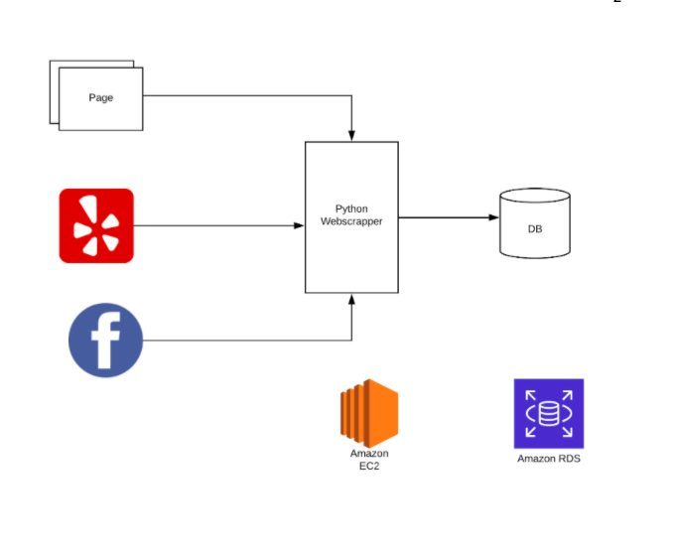

References used:

<https://www.w3schools.com/python/python_json.asp>

<https://codingnetworker.com/2015/10/python-dictionaries-json-crash-course/>

<https://www.youtube.com/watch?v=TTMJdTH9W4o>

<https://www.youtube.com/watch?v=4UcqECQe5Kc&list=LL4q6m5vW42p0vYODzbIG3Qw&index=2&t=0s>

<https://www.crummy.com/software/BeautifulSoup/bs4/doc/>